TM354 TMA02 Stuart Mathews (Y6718837)

Question 1
a)
Candidate class name | Group | Keep | Reason for keeping or discarding the candidate class
Member of the public (“User”) | Tangible object | yes | Part of the domain, can browse products and thus interacts with a fundamental part of the system and the problem domain
Shopper | Tangible object | no | Represents a member of the public(already accounted for), which is the same thing, in contrast to a “registered shopper” which is also accounted for in the domain
Product | Tangible object | yes | Part of the domain, where the product is core the users of the system and the system itself
Category | Attribute/Number | No | Attribute of a product, too detailed to be added to my conceptual diagram
Customer | Tangible object | no | Part of the domain but a generalisation but may hide many sub-individual operations that I’d like to expose in the conceptual representation of WSS. Could also mean member of the public which is already accounted for in my model
Depot | Tangible Object | Yes | Part of the domain, fundamental to the system represents multiple associations with multiple other concepts such as customers, depot assistants, products etc..
System | Tangible Object or organisational unit | no | Too high level a concept, as it represents the whole when the conceptual model describes the components that represent the whole into general components.
Order | Tangible object, not necessarily a number | yes | Part of the domain, and represents part of a fundamental relationship between the registered shopper and product
Warehouse system (“Warehouse”) | Tangible Object or Organisational unit | yes | Part of a fundamental relationship between the order, the registered shopper and exposes a fundamental process in the system (ordering)
Walton Shopping System (“WSS”) | Tangible Object or organisational unit | no | Same as “the system”
Unique order number | Number or attribute of a order | no | It’s an attribute or an order, and the conceptual model will generalise the order so no need to represent this attribute of the order
Depot Assistant | Tangible object | yes | Interacts with WSS and the customer through collection process and other processes
Refund note | Tangible object | no | Forms a relationship between the customer, the product and the refund or refund process but is not part of a generalisation that I’d like to expose of the system as a whole – i.e. too much detail
Review | Tangible object | no | Could be seen as an attribute of a product and too detailed
Rating | Tangible object | no | Could be seen as an attribute of a product and too detailed
Walton staff | Tangible object | Yes | Including as it would include depot assistants, administrators(multiple) and their specific relationships etc… that I’d like to expose in my model.
Administrator | Role | yes | Play a specific high level role/part in managing the products and the system so should be represented in the model that describes it
Senior Administrator | Role | yes | Play a specific high level role/part in managing the products and the system so should be represented in the model that describes it
Unique identification numbers | Number | no | An attribute of a product
Registered shopper | Tangible object | yes | Represents a unique set of processes that the functionality provides but not to others (member of the public)
Registration (“registers”) | Process/Transaction | no | Typically registers with the System, this is too high leel for this model. Important part of the system to function as it affects /determines who can perform what in the system
Collection (“Collects”) | Process/Transaction | yes | Important part of the system as it represents a core pieces of functionality that defines the system as valuable to the user of the system
Browse products (“Browses”) | Process/Transaction | yes | Valuable part of the for users of the system
Purchaser | Tangible object | yes | Represents users that have purchased products before using the system and can refund or make reviews which is important functionality to be represented in the system provides.
Order creation | Process/Transaction | No | Represented later as Ordering. Represents a valuable part of the system’s functionality and affects many other parts of the system such as the depot, the shopper
Checking out | Process or transaction | yes | Represents an important part of the systems functionality which affects the users and the system, the Warehouse, the depot assistants
Ordering | Process or transaction | yes | A fundamental activity that the registered shoppers can perform and that the system needs to produce a means for delivering this functionality.
Returning an item | Process/Transaction | yes | Represents an valuable part of the systems for purchasers which the depot assistants and Warehouse system among other associations
Reviewing | Process | No | Not a fundamental part of the domain, but important to some member of the public but I don’t want to expose this in the conceptual representation of the whole system but could…
Viewing purchase history | Process or transaction | No | Important part of the interaction between a user and the system
Add or remove a category | Process or transaction | no | This is a specific process for an administrator which is too detailed to add to my conceptual model
Add or remove a a product | Process of transaction | no | This is a specific process for an administrator which is too detailed to add to my conceptual model
Change the price of a product | Process of transaction | no | This is a specific process for an administrator which is too detailed to add to my conceptual model

- In unit 5 it was suggested that a good place to start is to indentify nouns and to represent them in their singular forms. I used this guidance to identify and reduce the term/role “administrators” to “Administrator” for example. Also, it was suggested to avoid duplication when identifying nouns which represent the same thing or that inappropriately identify too much or too little detail (over generalisation) of the concept you want to identify. I found this particularly true of concepts in my list of “The public”, “Customer” and “unregistered shopper””. It also indicated that identifying behaviours should be avoided but I found that system behaviour and process are too important an association for me to give up in a conceptual diagram. This includes behaviours such as the Public “registers”, and Registered shopper “purchases”. I excluded concepts that were not relevant as suggested such as “reviewing” as this is not part of the detail of my model. Generally speaking the guidance didn’t mention that things with a relationship or affect one another within the problem domain is worth representing – I think this is a good rule and I used this throughout the identification process.
[194]
b)
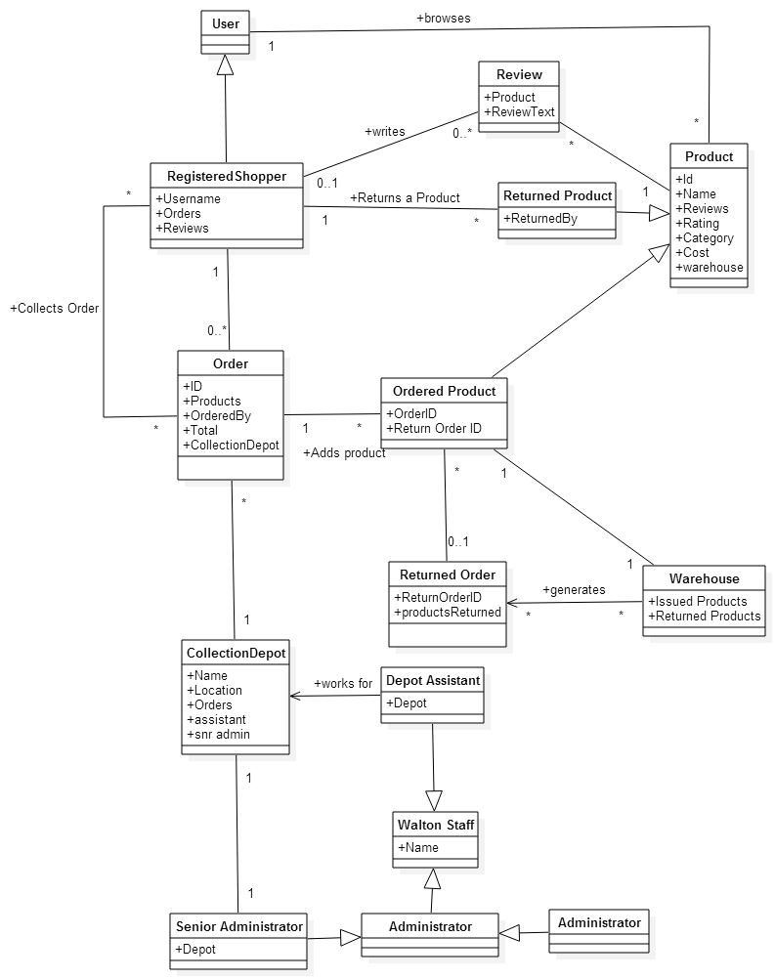
Figure 1: My Model
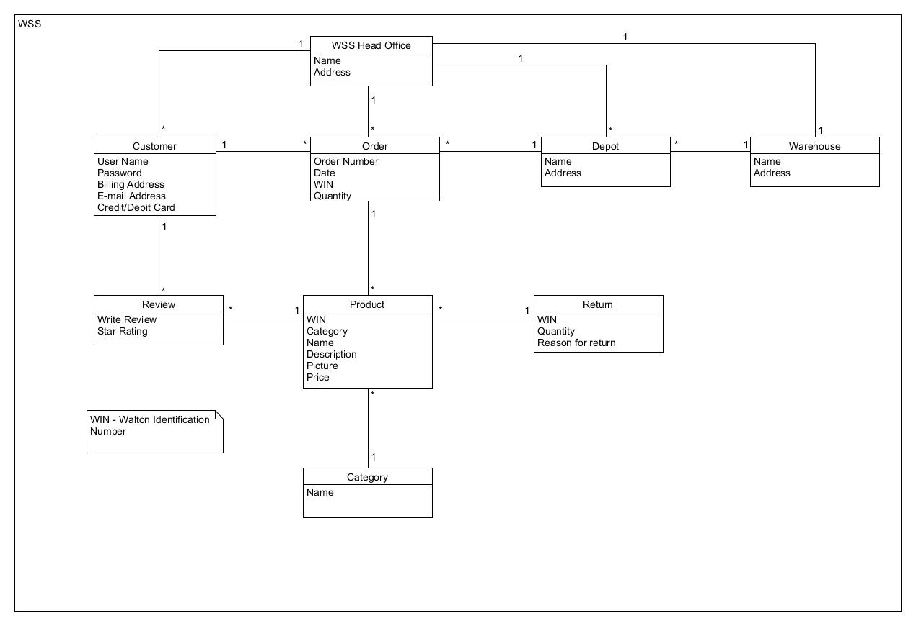
Figure 2: The alternative model I selected
My comments on differences between the models
This model differs from my own as I have not specified a WSS head office or indicated the rating system to be start(I interpreted mine perhaps to be a number). I think the warehouse, depot and head office interesting because although this diagram does not indicate it with a generalisation UML syntax(this should be added for clarity's sake), the intention of objects infer that they are all generalisations of some sort of building/office because they share the same attributes. I think the category should have been an attribute of the product.
That said, in my model I forgot that a user has a password too, Annie didn't forget this detail, which I think is important.
Also the "reason for return" is different to mine and that matters because WSS would probably want to know why the product was returned. I also missed this, same applies for the products Picture, Order's date and warehouse's address.
There are some good ideas from this diagram,had we worked together we'd probably helped each other tremendously.

Question 2

  - Yes, every workshop has one room and every workshop irrespective of the session or timeslot is in the same room.
  - No, there is one room per workshop/presentation/session.
  - No, there is no specifics in the model that specifies the duration of a session. However in the description of the model is specified that “and the duration of a workshop is that of a single session”.
- Context Workshop inv:
Self.maxParticipents->count() <= Self.Room.capacity.count()
- A delegate cannot be a participant in a presentation as well as a facilitator in a workshop. You cannot have a facilitator in one workshop, also being a facilitator in another workshop in the time session.
- Add a Plenary Meeting object to diagram. Add associations, annotated with {xor} to it from existing the Session, Presentation and delegate objects constraining these associations to occur only when a plenary meeting is occurring. So that when this occurs, all participants and all facilitators for the session are associated with the Planary meeting.

Question 3
a)
i)

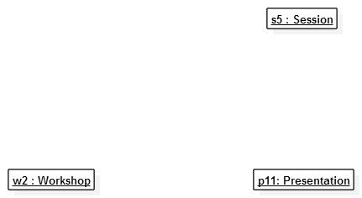
Figure 3: Before
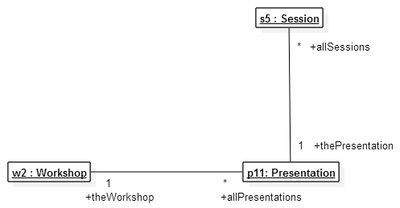
Figure 4: After
ii)
Main Success scenario:
- The Conference organiser requests a new presentation
- The Presentation assigns a workshop to the new presentation
- The presentation registers/specifies a new session time-slot
- The presentation registers itself to the workshop .
- The presentation registers itself to the session.
Extensions
3.a) Specified timeslots are available for the session. The system suggests next available slot.

b)
i) A communication diagram is advantageous because it better shows the routes that messages take throughout a model. The disadvantage is that the sequence of message sends is difficult to see without a complex sequence numbering system.
ii) The Presentation object manages and hides the Workshop and Session objects because they compose a Presentation object and manipulation of these objects outside a Workshop would compromise the consistency of the Workshop. This also de-couples and separates the Workshop and Session to a specific Conference or user interface. Meaning if a presentation can be easily represented in another conference or another interface can be used to setup presentations etc. Also each use cases might be more easily represented in the Presentation class.
iii) Yes it uses the GRASP pattern as it identifies that the Conference object is responsible for creating the Presentation object, as it calls newPresentation(w2,s5) whereby the Conference object uses its ownership information that it has access to, to create Presentation objects that require that information as parameters for the creation.
iv) Conceivably a message could be sent on application start-up, where the main application object sends a message to the central class(for example) to initialise or create all objects that the interface might need and there for reduce the latency in the user interface in creating these incrementally on fist access.
- Traceability loosely refers to the ability to track objects, their associations and behaviours and restrictions to the software requirements. This includes tracking exposing these same things in different diagrams which represent these at varying levels of detail. For example the AddPresentation use case exposes object restrictions the pre/post conditions for Room, Session and Workshop objects. This will influence how the code will be written and structured to correctly model these behaviours and assert these restrictions.
- Light-weight approaches would include, to re-use/modify or copy existing use cases to base new similar ones from. It might be possible for go straight to code from the user story analysis phase. Some developers might choose to model and diagram during the direct-coding of user stories and sharing/using them at this stage for collaboration or self validation. Unit tests and integration tests for use-cases can be used that test pre and post conditions can allow rapid changes in code to be validated as ideas change without having to re-draw/model complex diagrams etc. Approaches such as reducing the number of iterations of concrete instance scenario models in favour of more generic models. Another would be to use simpler more collaborative models such as CRC models for class interactions. This includes models that provide quicker access to more information such as communication diagrams that show routes, messages and objects and can be quickly referred back to their object diagrams from which they originate or evolved from. These might largely replace the need for many separate sequence, activity, object and class diagrams perhaps except for specific cases where they are useful say in describing a complex/important/critical concept.[195]

Question 4
a)
i) Advantages are that the user interface only coupled to the central class and any change to the business objects will not affect the interface as long as the contract between the central class and the user interface is maintained. This does however mean that the central class will grow larger in size as it will have to accommodate for ‘knowing’ about all the internal objects and representing all the use cases. Tractability to good as there should be(and easily identifiable if there isn’t) an appropriate method(s) for each use cases in the problem domain. Another problem is that
ii) AnualReportPrinter with the method run which will print out the annual report.
b) The law of Demeter(L.O.D) It is concerned with accessibility of two objects, in this case an object that might want to send a message to another object. GRASP(Expert) however, is concerned with identification of the latter object which will best suited for servicing that message. If the two objects are not closely associated as a result, then according to L.O.D, they should not communicate directly. This is initially problematic. However, this doesn’t mean the Expert, that was used to best identify the servicing object, is inconsistent with the L.O.D.
For example, one can design a system where an latter object conforms to the Expert, can be passed into the object that would like to send the request to it, alternatively the expert object can be an instance variable or static global variable or even a global static class(singleton). This way it would permit access to it. [146]

Question 5
- Open, Closed, Confirmed and Aborted

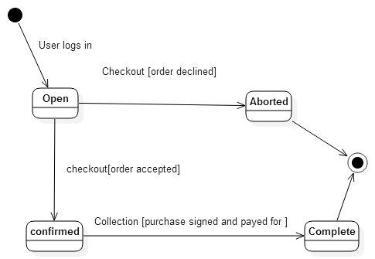
- Generally I’d ensure that each separate diagram where certain objects have associations with each other, each refer as much as is sensible(in terms of context and detail) to the same names, actions, behaviours, attributes and share/expose/indicate (where possible) requirements such as pre and post conditions of the objects that are referenced in earlier diagrams. For state machines, I’d at least ensure that the actions referenced exist uniquely on the modelled class in previous sequence diagrams or class diagrams. For use case diagrams, I’d ensure that all earlier requirements, actors and behaviours are consistently represented. For object diagrams that the associations, directions and association multiplicities represent the candidate objects previously identified earlier in the problem such as use cases. For communication diagrams, I’d ensure that message sends represent the behaviour and directions consistent with what was established in earlier object models through document object associations etc. For class diagrams, that the associations are represented by earlier object diagrams, that the attributes are carried over from the identification of problem domain objects(such as identification that a orderNumber is an attribute etc.) This is important for traceability from the phases and levels of detail in the development process to the correct identification of the objects referenced in multiple diagrams. This also aids in distilling ideas and prevents confusion and ambiguity through consistent ideas which aids communication between people interpreting the model.
[229]

  - It allows for logical grouping of related model elements which provides data encapsulation and enforces navigatebility/access requirements/constraints and defines high level architectural boundaries. It also allows two different models to share the same name if they are in different packages and manages size and complexity.
  - Shopping components would need access to stock control as shopping can reduce the number of stock in WSS. Shopping components would also need to access the finance business objects to delegate the pricing changes to the system when items are bought(money received) and how much item cost. Shopping components would also need access to the customer objects who interact with the shopping process such as who made the purchase, which depot has the customer requested to item be sent to and so forth.

